# Marketing

1. Segmentation (Marketing List) Target customers.(مين اللي انا مستهدفهم)
2. Planning Activities (things I need to start the campaign like mall rental, Flyer printing).
3. Target Products.(product I need to make campaign for)
4. Sales Literatures (like flyers itself).
5. Campaign Activities (Activity in marketing process itself like contact customers or sending emails to contacts from 21 to 25).
6. Campaign Responses (Response of campaign activity like after calling someone and he say that he is interested in this product).
7. Campaign Performance (to track performance of my campaign form dashboard).
8. Campaign VS Quick Campaign is very important
   * Campaign has multiple marketing lists and multiple campaign activities.
   * Quick campaign has a single marketing list and a single campaign activity.

**You need to convert your area to be Marketing.

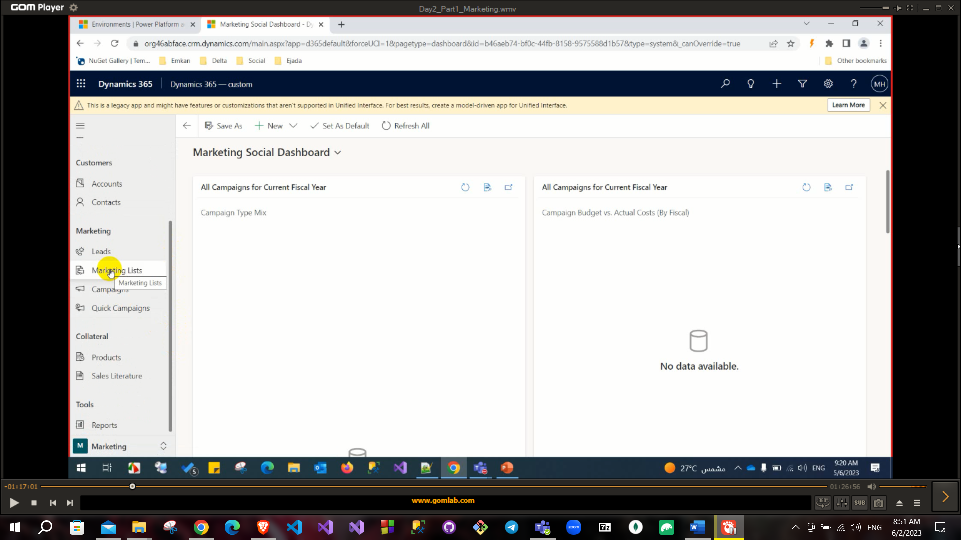

First step to define a marketing list (it needs to have some contacts first). There are two types of market lists

* + Static has a static criteria (once be created if their contacts updated does not affect on it).
  + Dynamic has a Dynamic criteria (Automatically updated their contact).

For example, on difference between them if you create a marketing list for contacts that have less than 25000 $ as salary if someone in this marketing list has been promoted and his salary becomes more than 25000 $

* in case of dynamic marketing list, it will be terminated from this list.
* in case of Static marketing list, it will not be terminated from this list.

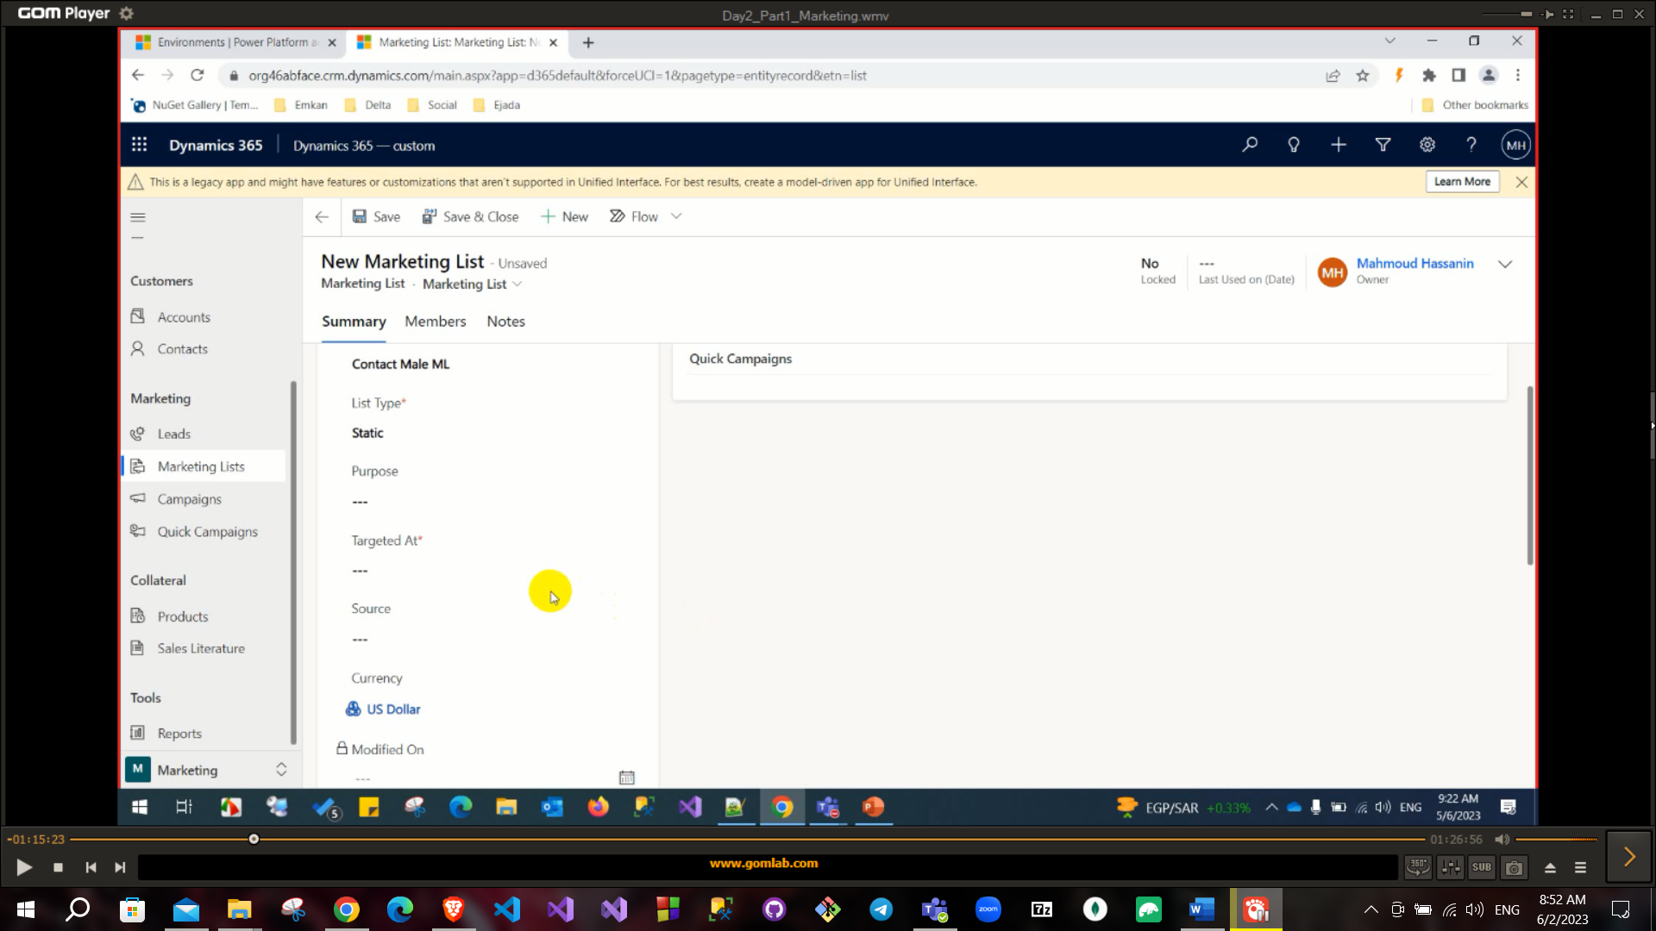

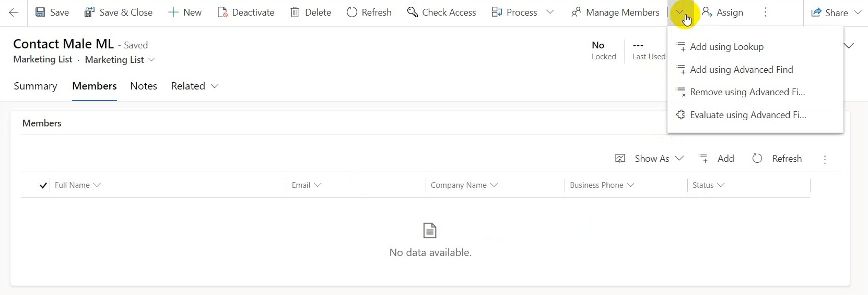

Adding members from manage members

* Add using lookup: add them separately.
* Add using advanced: find add them using criteria (like SQL Query).
* Remove using advanced find: to remove members using criteria.
* Evaluate using advanced find: To evaluate members.

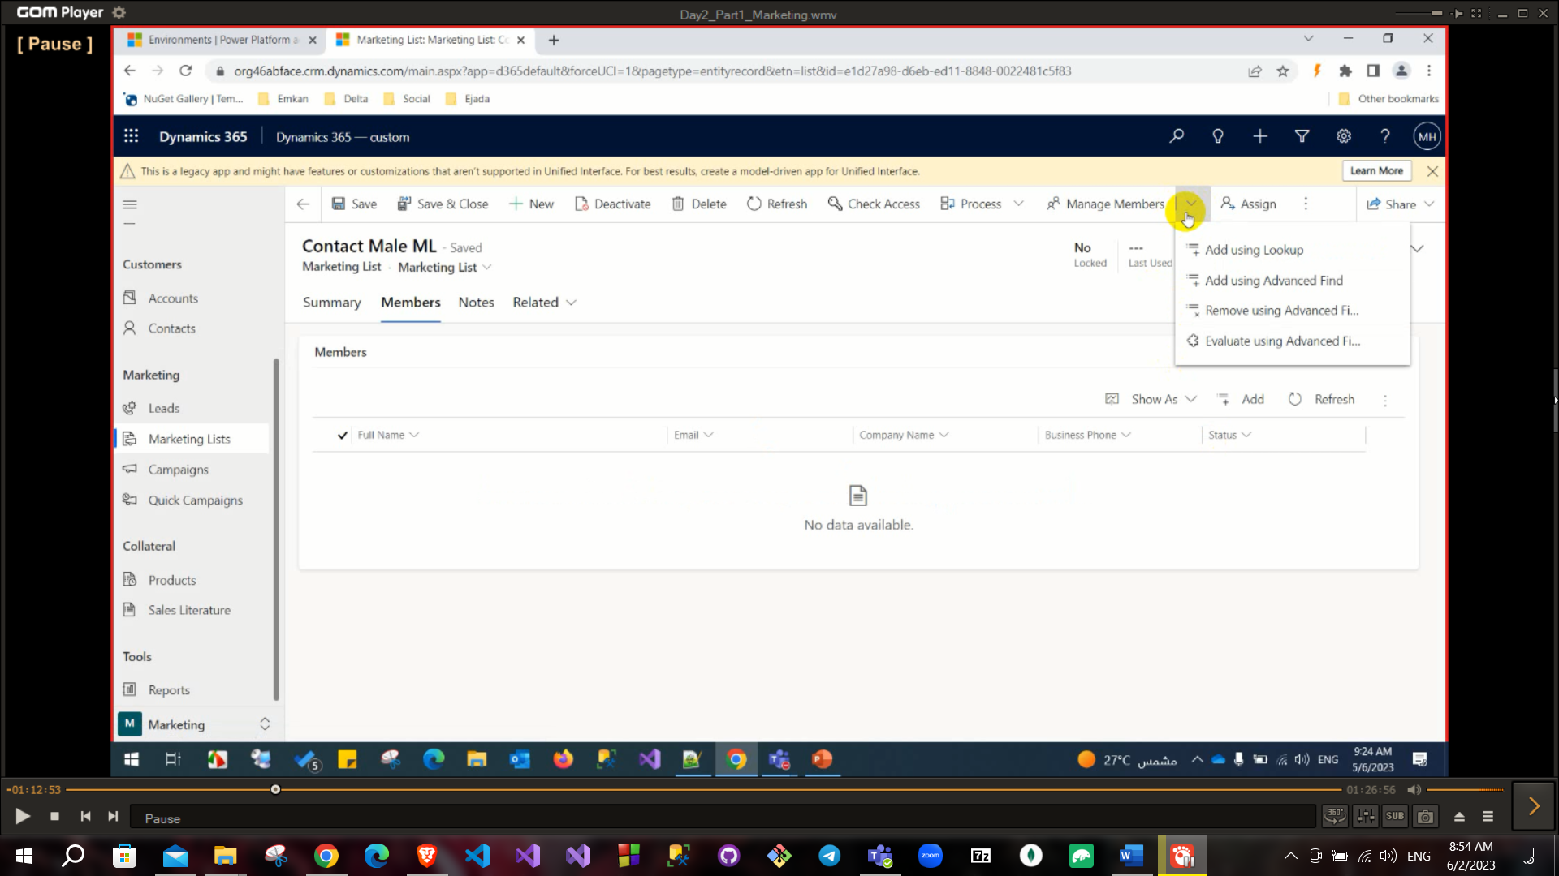

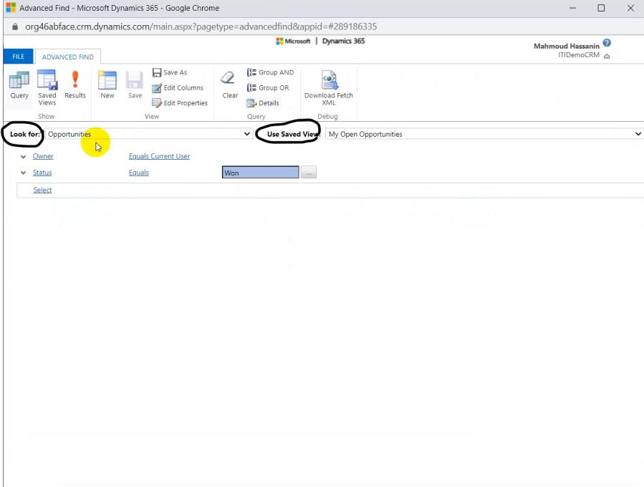

Select your entity and apply criteria then click on results above.

**Important to know how to deal with relationships in advanced filter. For example (To select contact that has opportunities).

So, you select in look for **Contact** and select from related to **opportunities**

that contains data and has at least one opportunity > 10000.

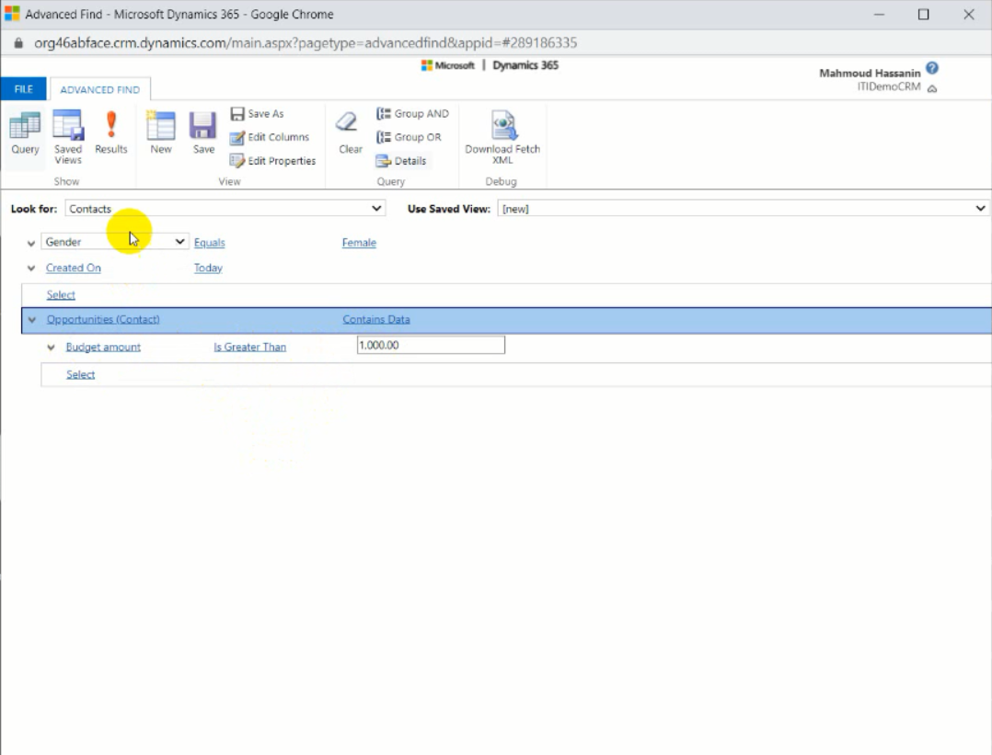

You can edit or customize your view that is created from advanced find by clicking edit columns.

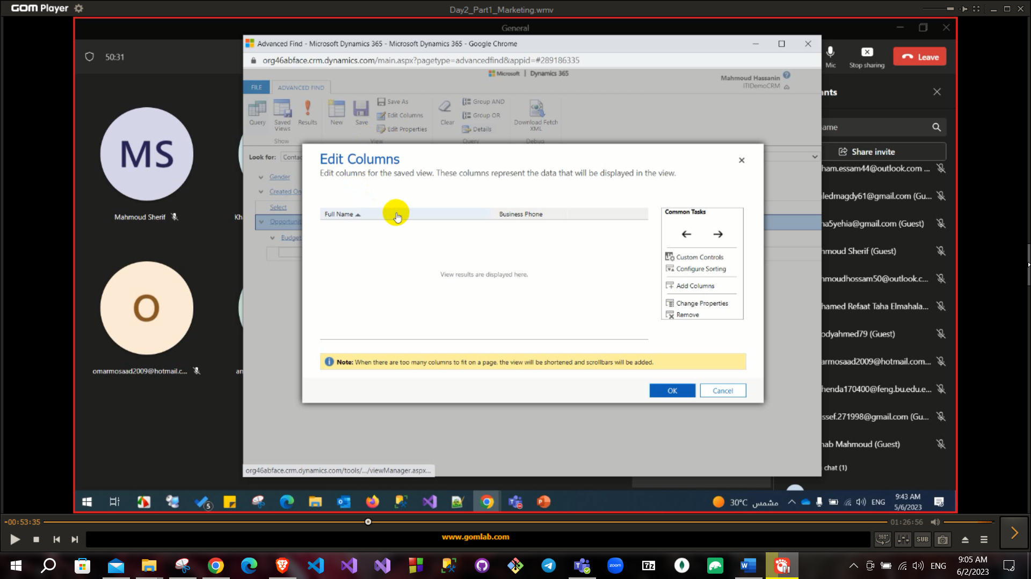

You cannot select a field from many entities into one entity.

In previous example you cannot select fields from opportunities to show inside contact (because it is one to many relationship) but the opposite is possible and it will appear in sub-grid.

## Creating campaign

Fill campaign form normally.

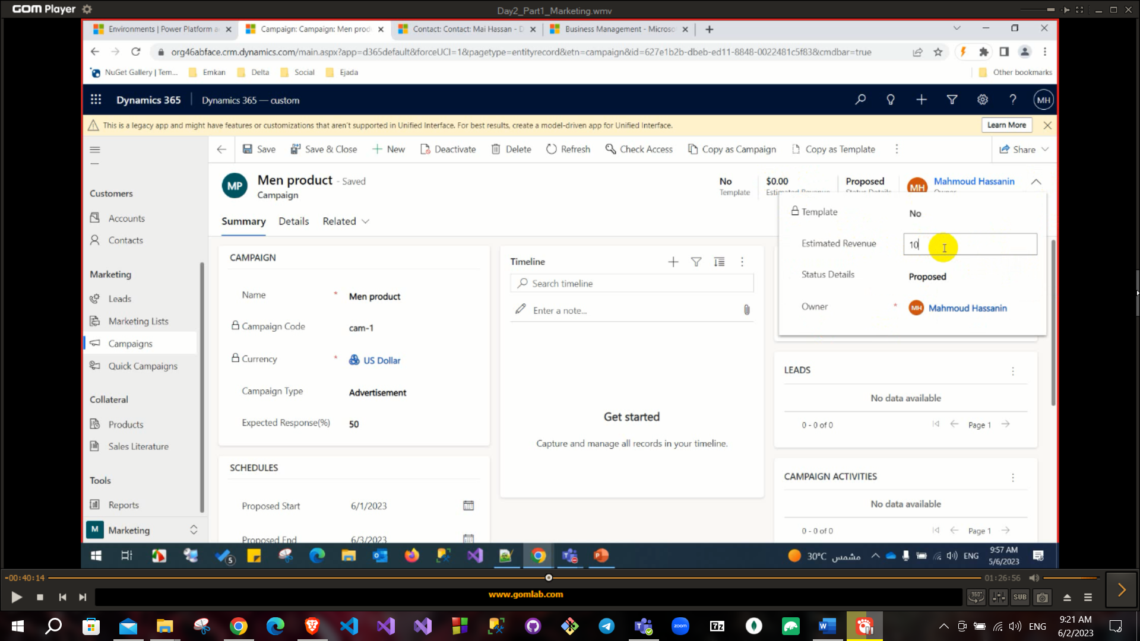

When you try to add marketing list to campaign

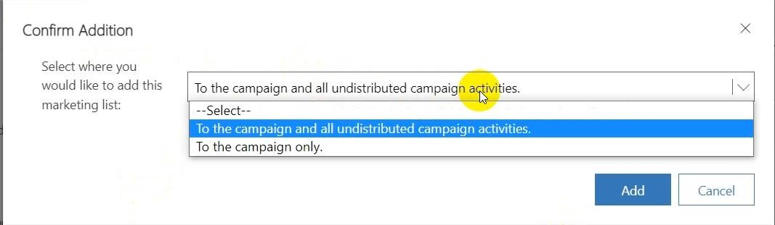

First choice will add this marketing list to all campaign activities also. Second choice will not add this marketing list to activities.

Create campaign activity to add to the campaign

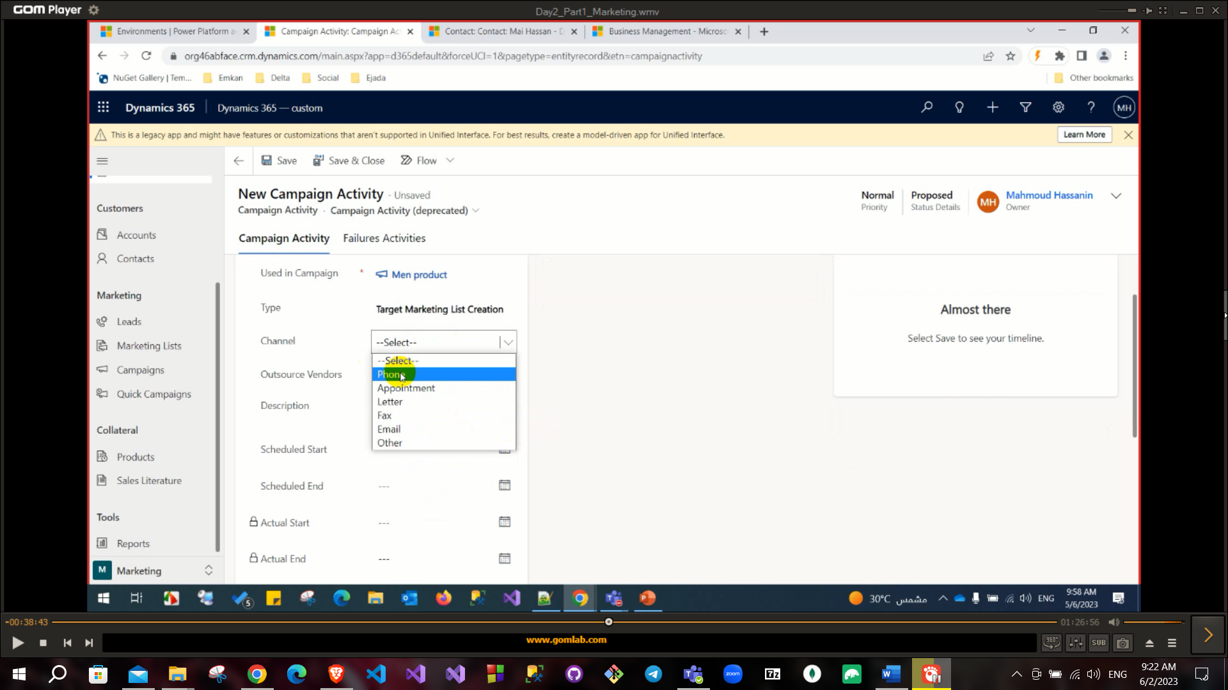

Create a planning activity from the timeline in the campaign (like mall rental or Flyer printing) by clicking on task and assign it to User.

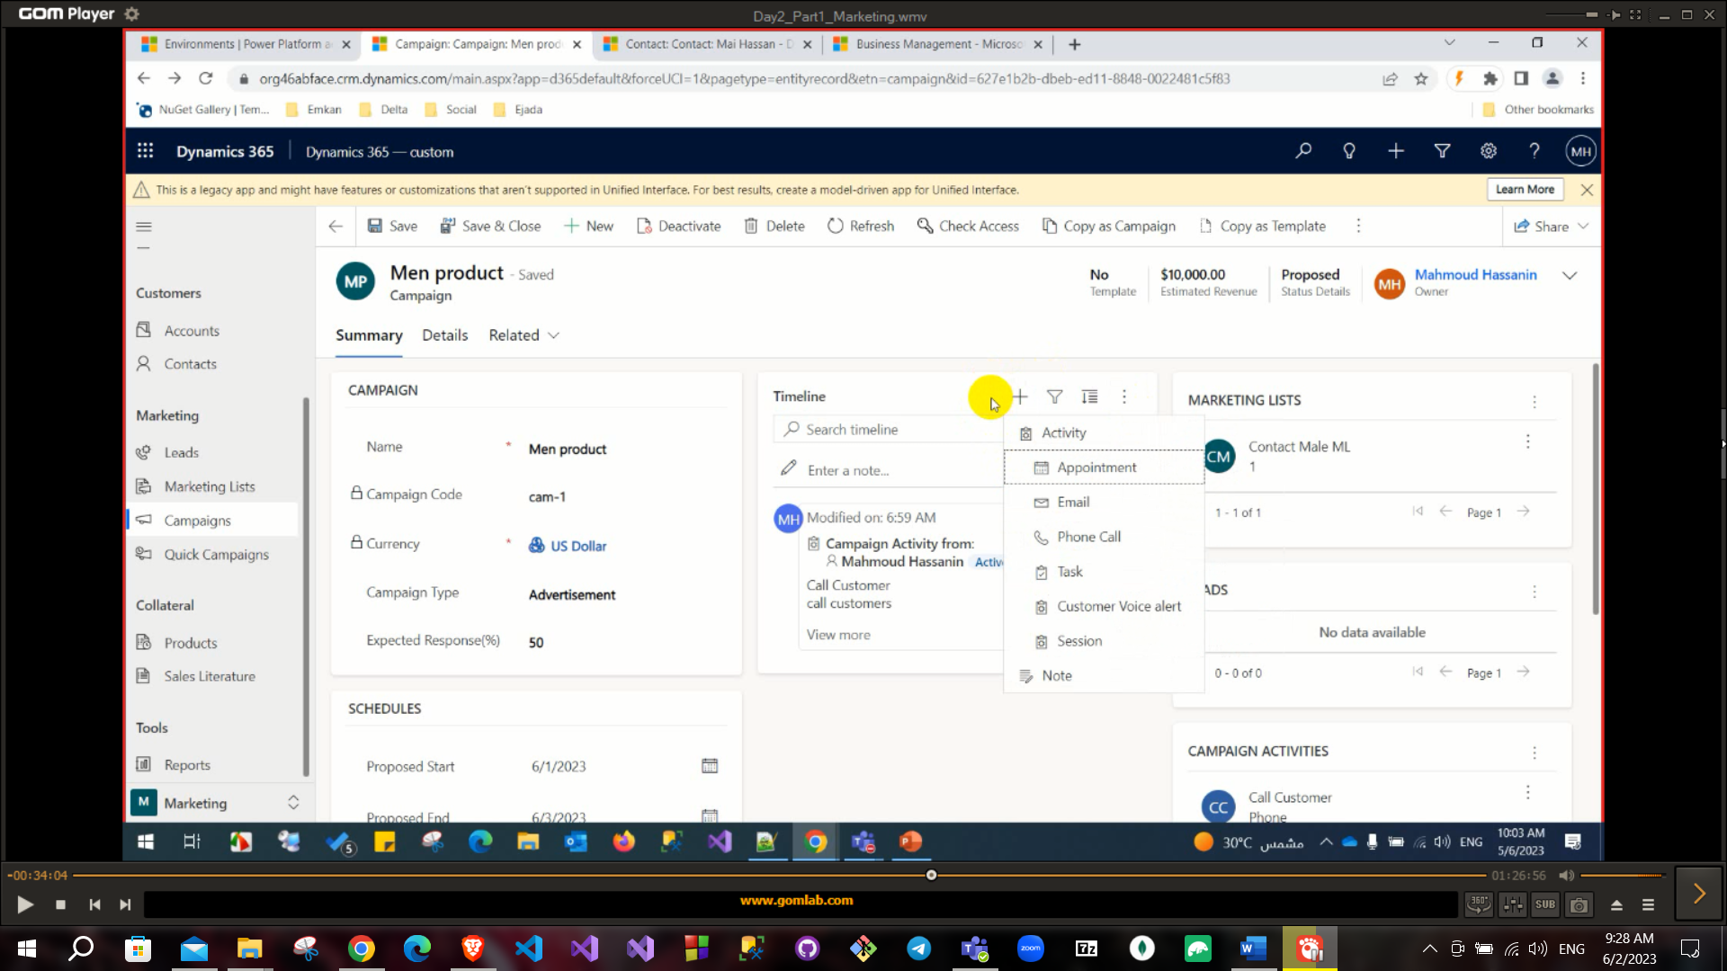

Now we added the campaign activities, planning activities and marketing list to the campaign.

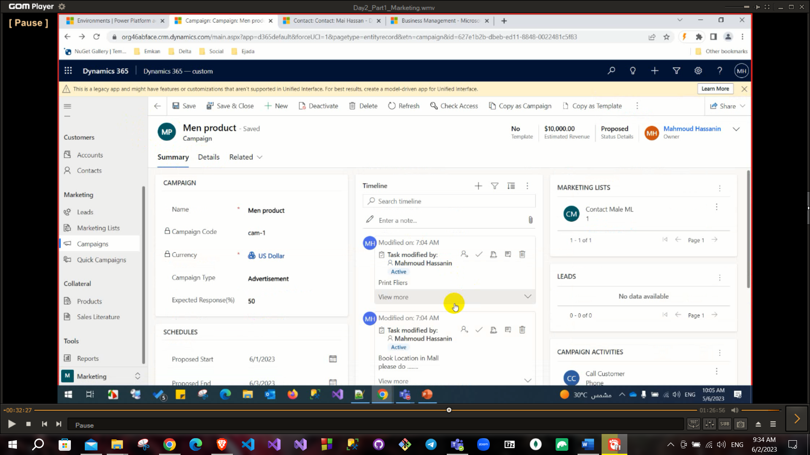

And in the details tab there is activity cost which is the cost of the activities for this campaign and you can set the allowed budget.

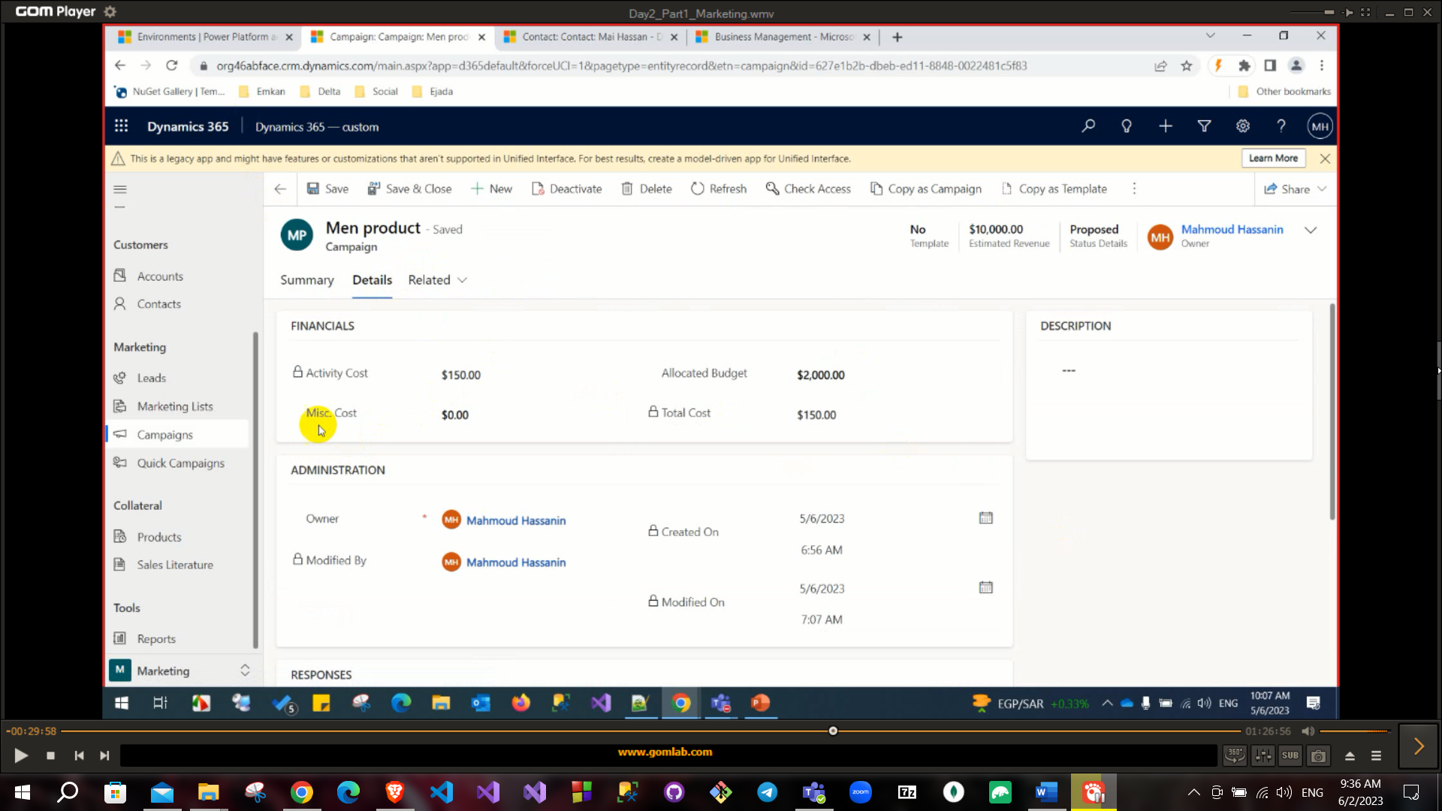

After creating campaign, you need to add product from related tab and add sales literature (can upload attachment to sales literature).

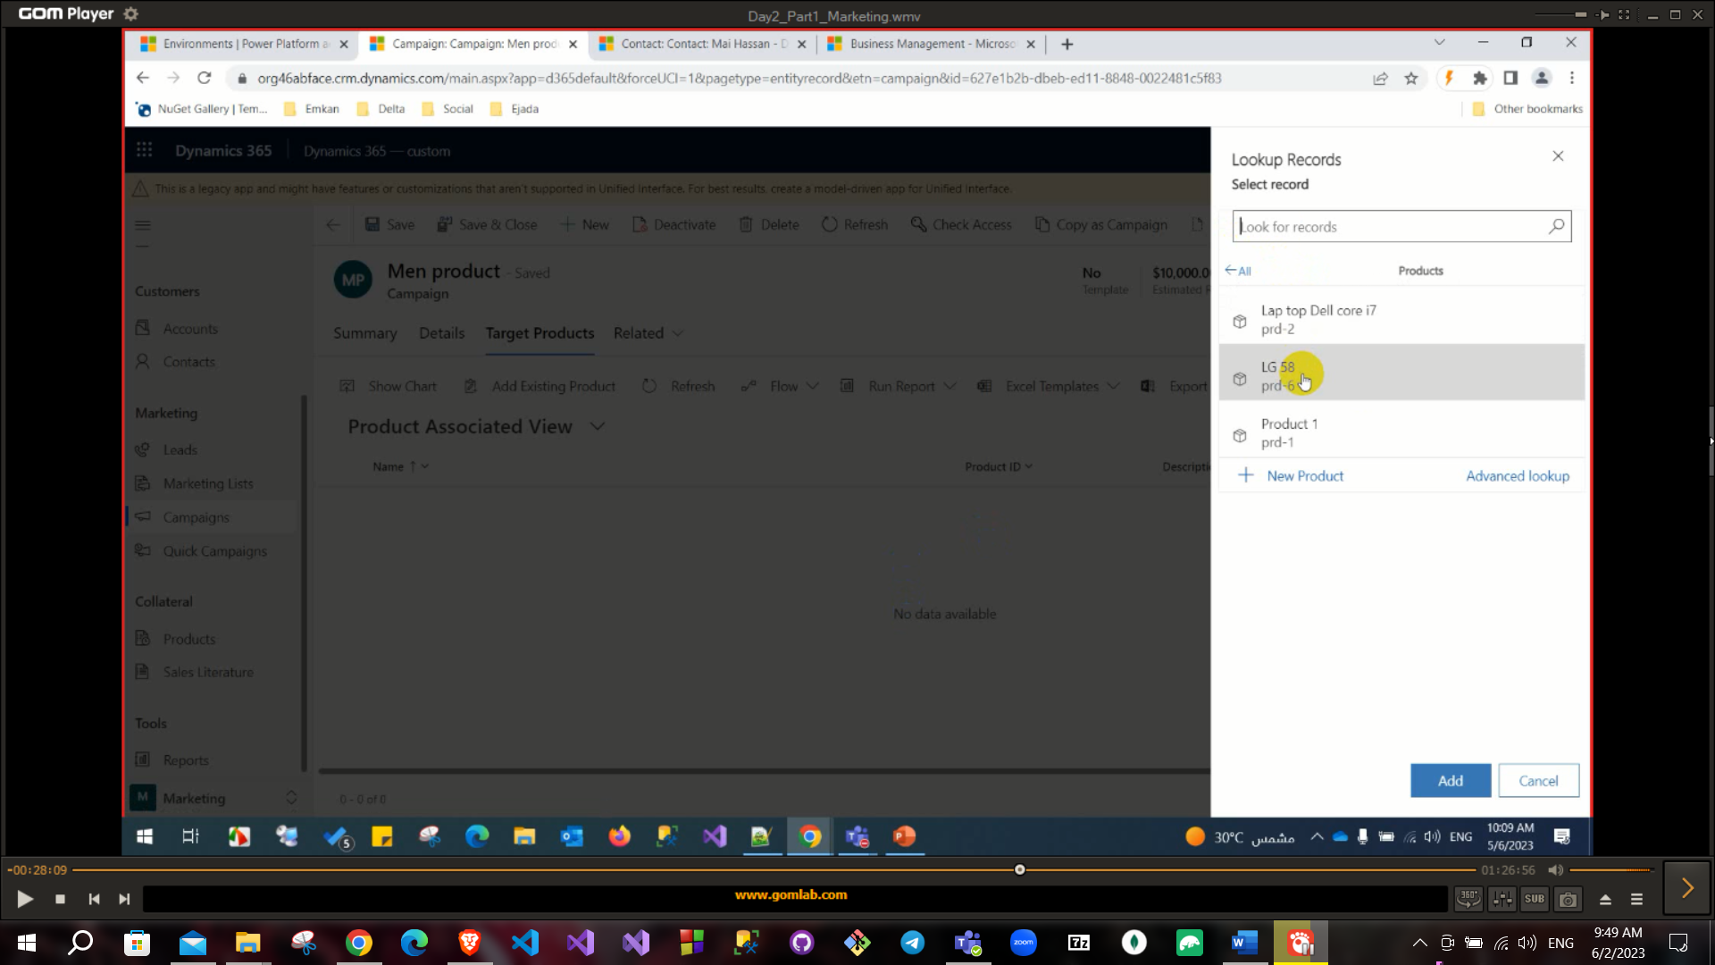

**You can track campaign performance from campaign: Run report: Campaign performance.

Also, you can see analytics of your campaign like track **tasks** status and see budget.

There is a field called **Anti-Spam settings** (Frequency cap days) to avoid be spam if you send too much emails to your customers.

To execute your campaign activity, click on **distribute campaign Activity** button in campaign activity and you need to assign this task to user also you can add this task to specific queue.

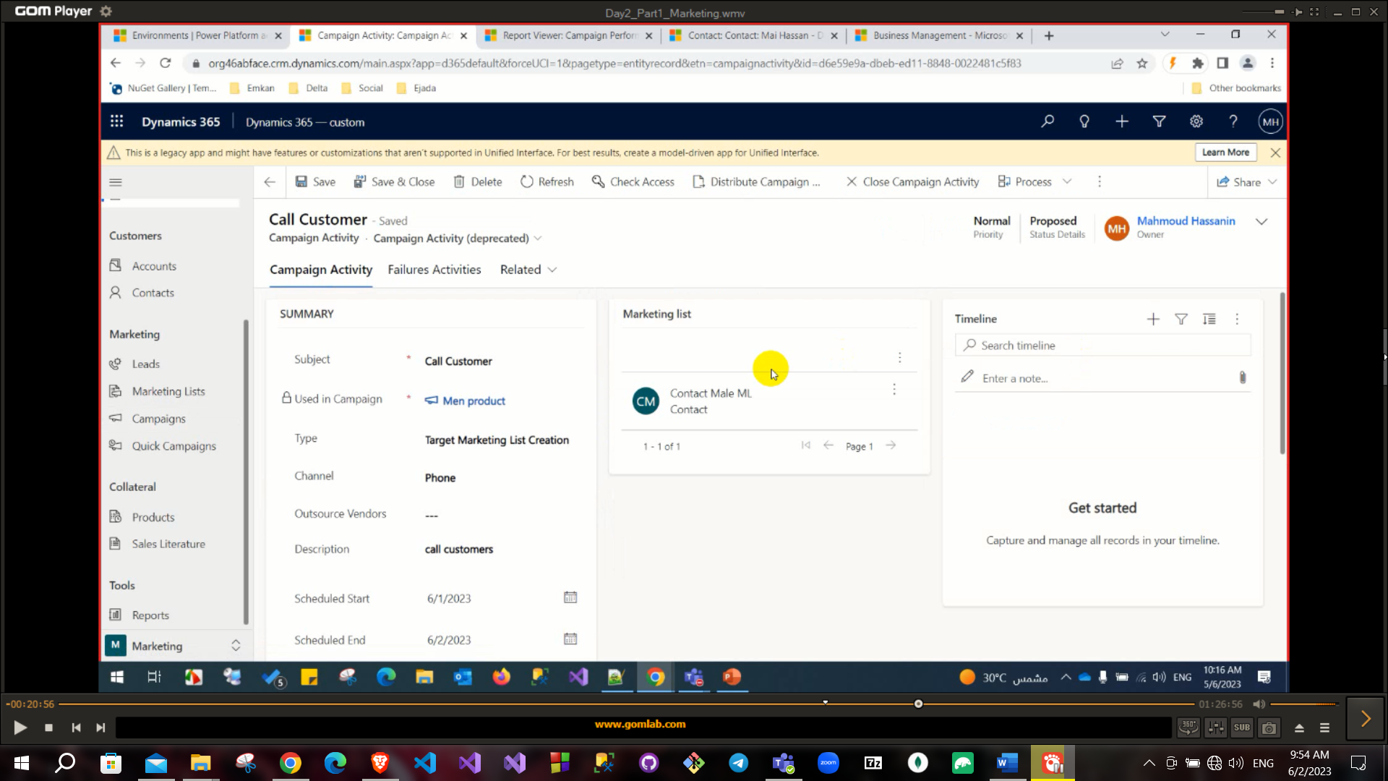

When you click on distribute this will create a phone call to every contact in the marketing list.

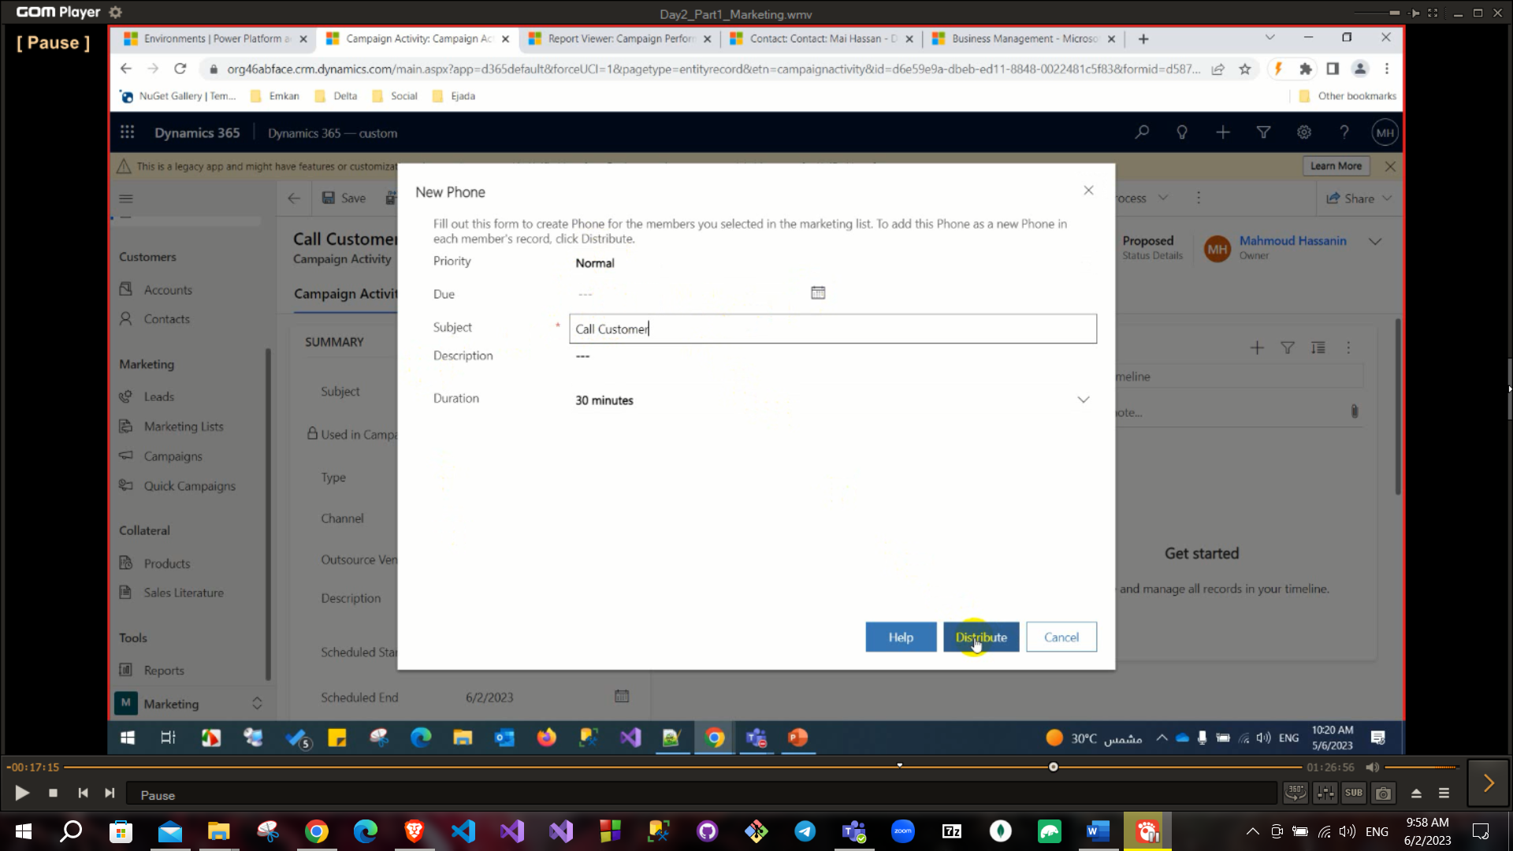

You can see the phone created at the bottom right

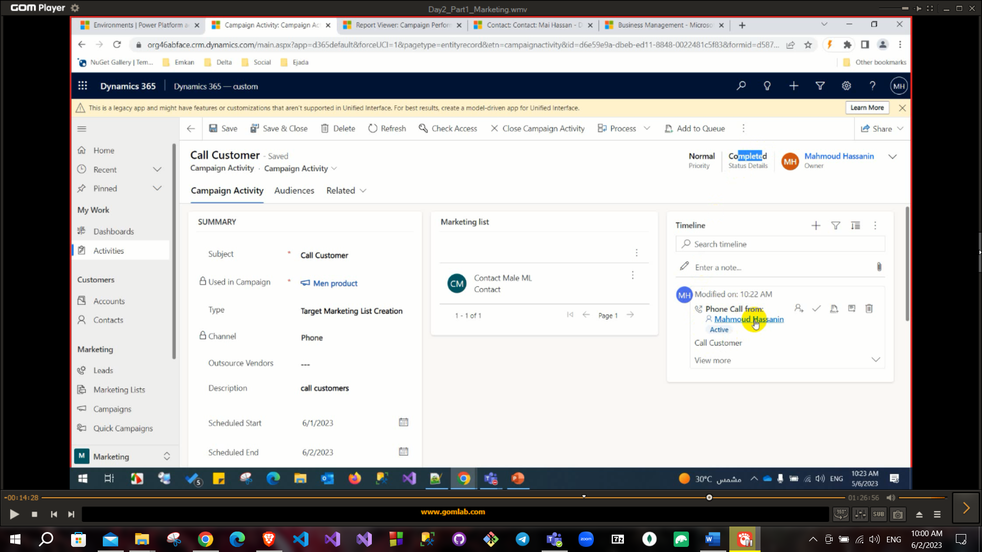

If you created a **phone call** activity (campaign activity) and after clicked on **distribute campaign** button in campaign activity and assigned it to user .

After calling the contact, you can click on **close call phone** and set its status as completed.

If you created an **Email** activity (campaign activity) and after clicked on **distribute campaign** button in campaign activity and assigned it to user

you can click on **Convert To: Promote to response** this automatically create campaign response (on campaign response you can set if this customer is interested or not and another options).

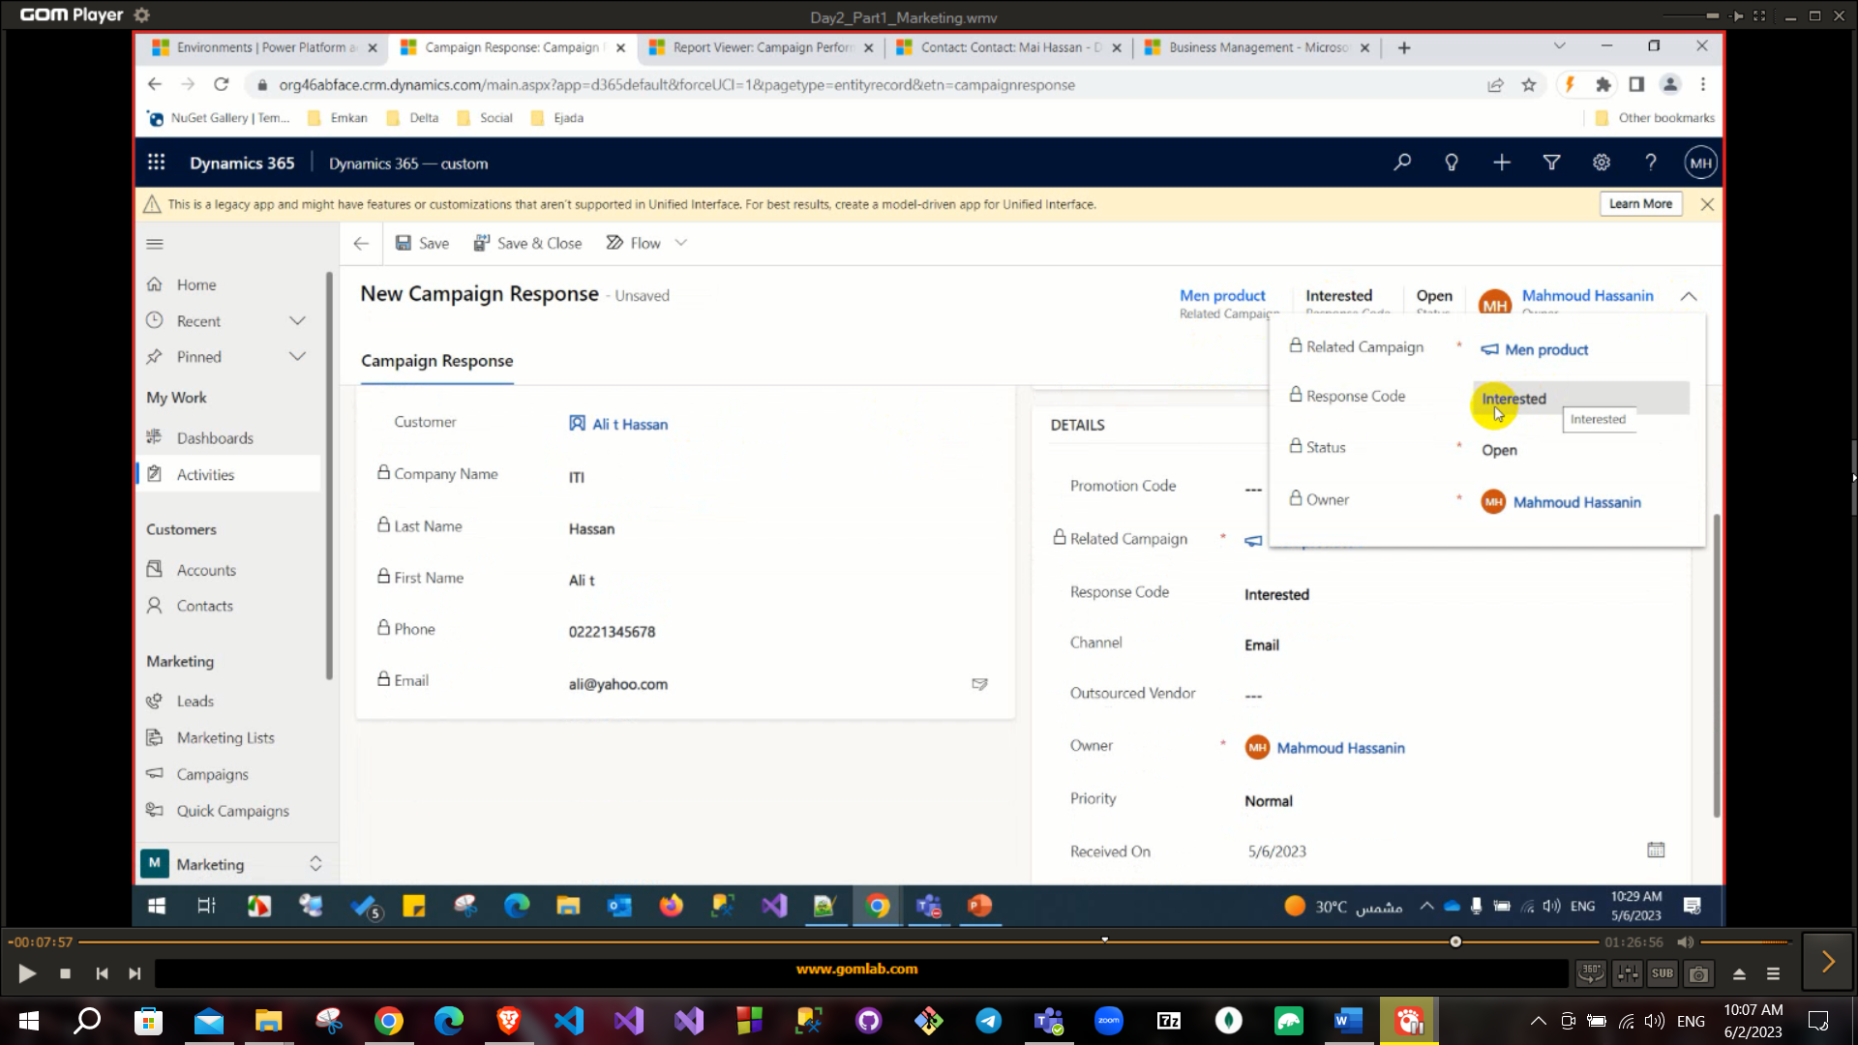

Also, you can convert **campaign response** to: Lead or opportunity, order, quote (New one or existing one).

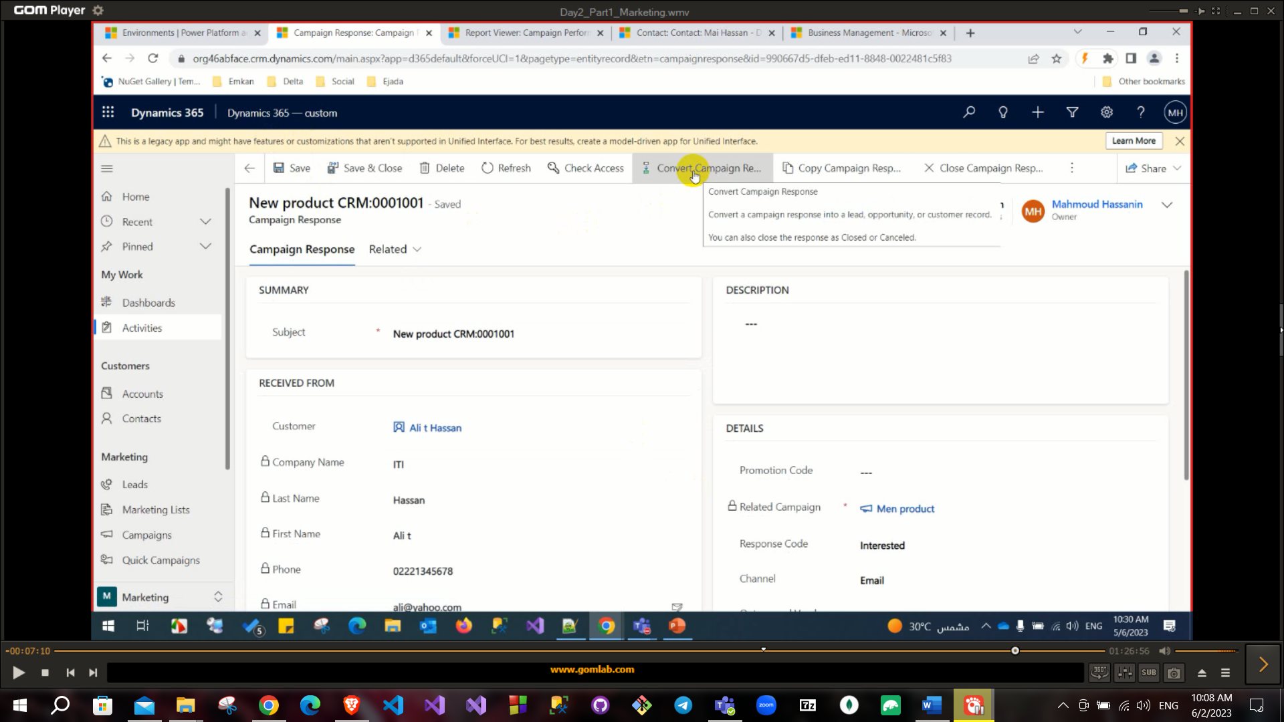

## Sales process: Qualify: Develop: Propose: Close.

In UCI all applications are separated.

# Service Management

1. Case Management, Subjects, Entitlements And SLA.
2. Service, Resources, Service Activities and Recurring Appointment.
3. Goal Management.

From the advanced settings you can Find Apps

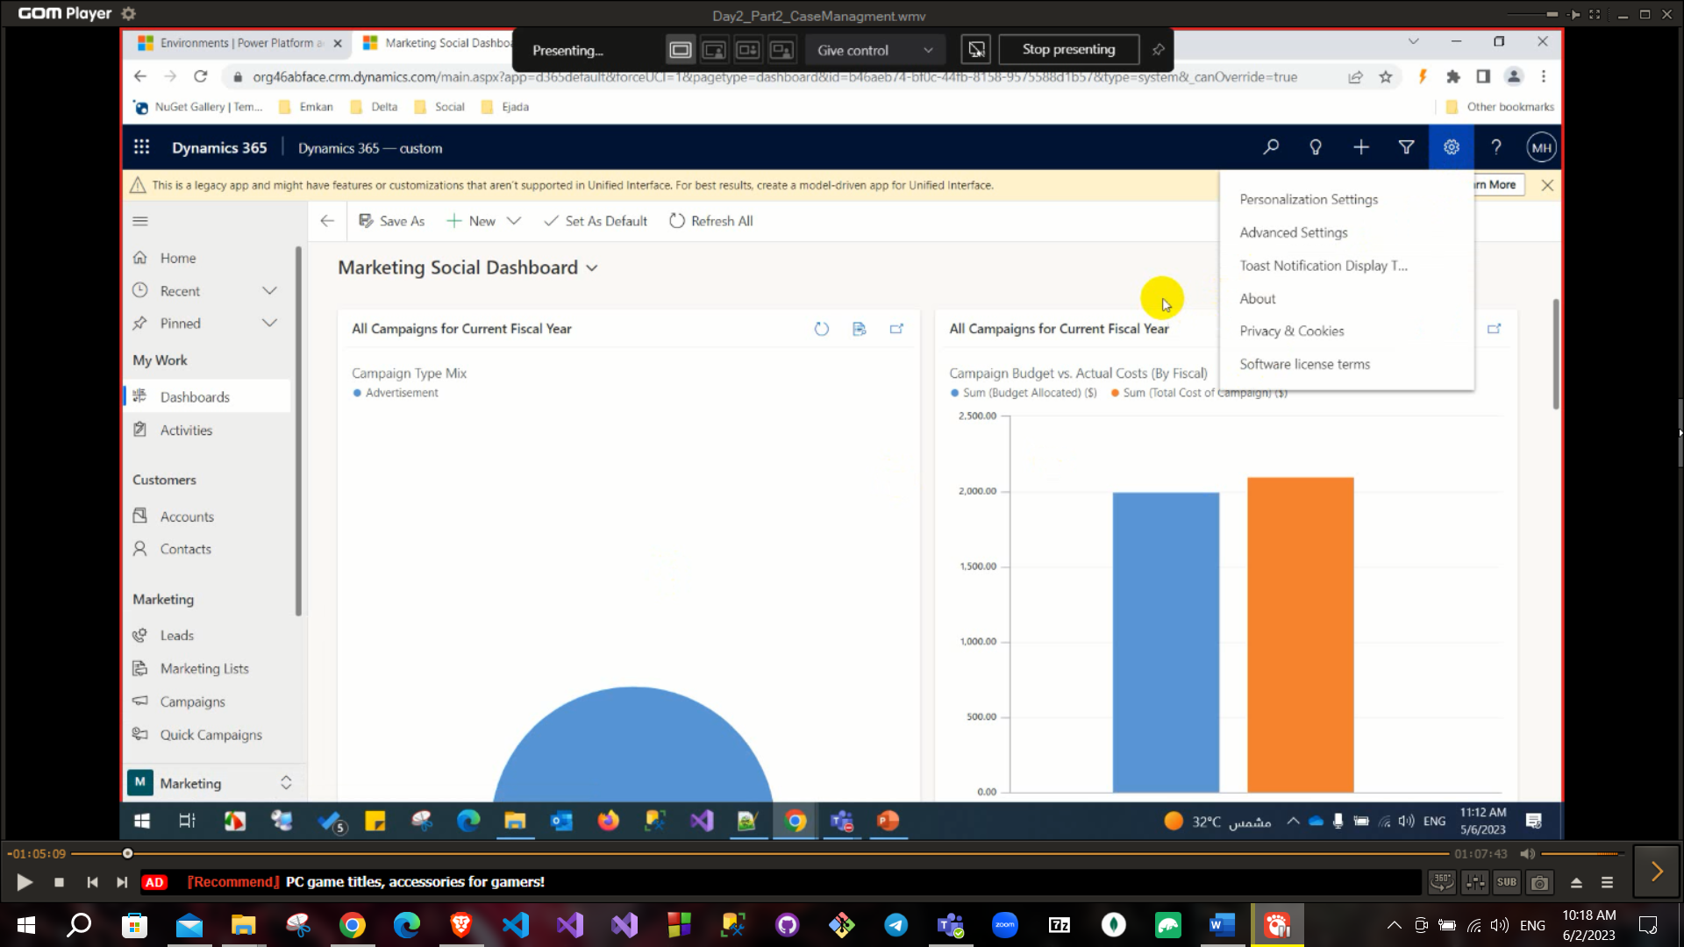

Our UCI consists from apps

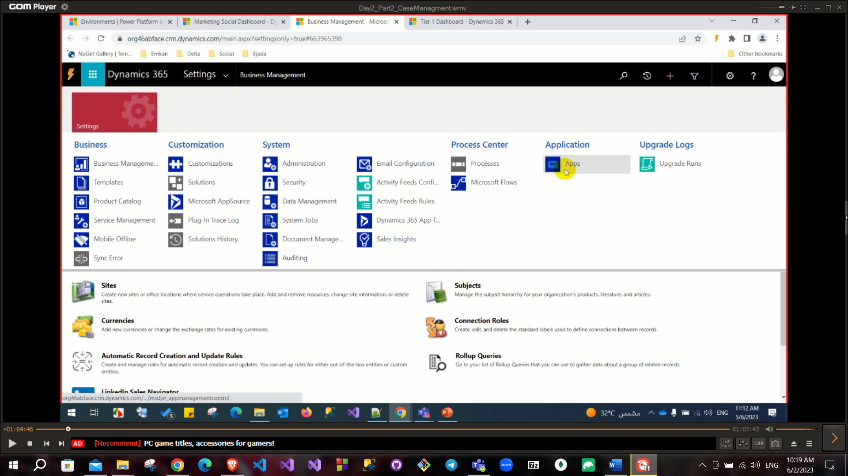

You can go to the service from **Customer service hub app** and on the left you can

Find cases and queues.

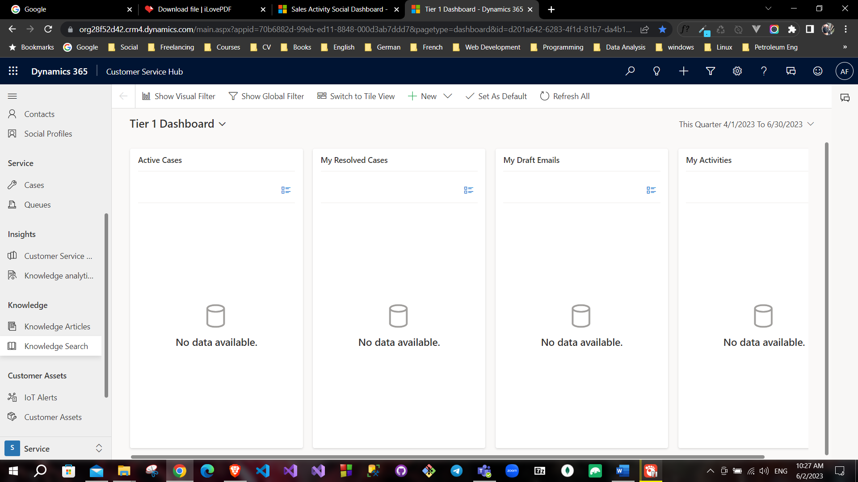

## Case Management, Subjects, Entitlements And SLA:

Case: Like ticket in retention customers(A problem that the customer calls about).

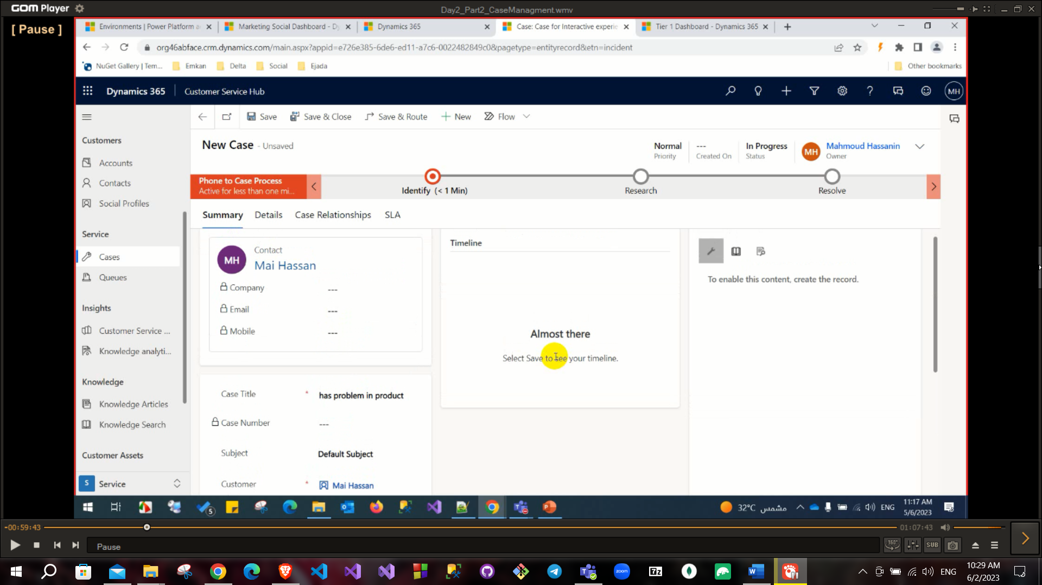

Subject: represent a category of this case also it has hierarchy.

Entitlements: like a credit for your customer (he has three times of checks or something like that)(عنده مثلا 3 مرات صيانة مجانية قبل ما أبدأ احاسبه).

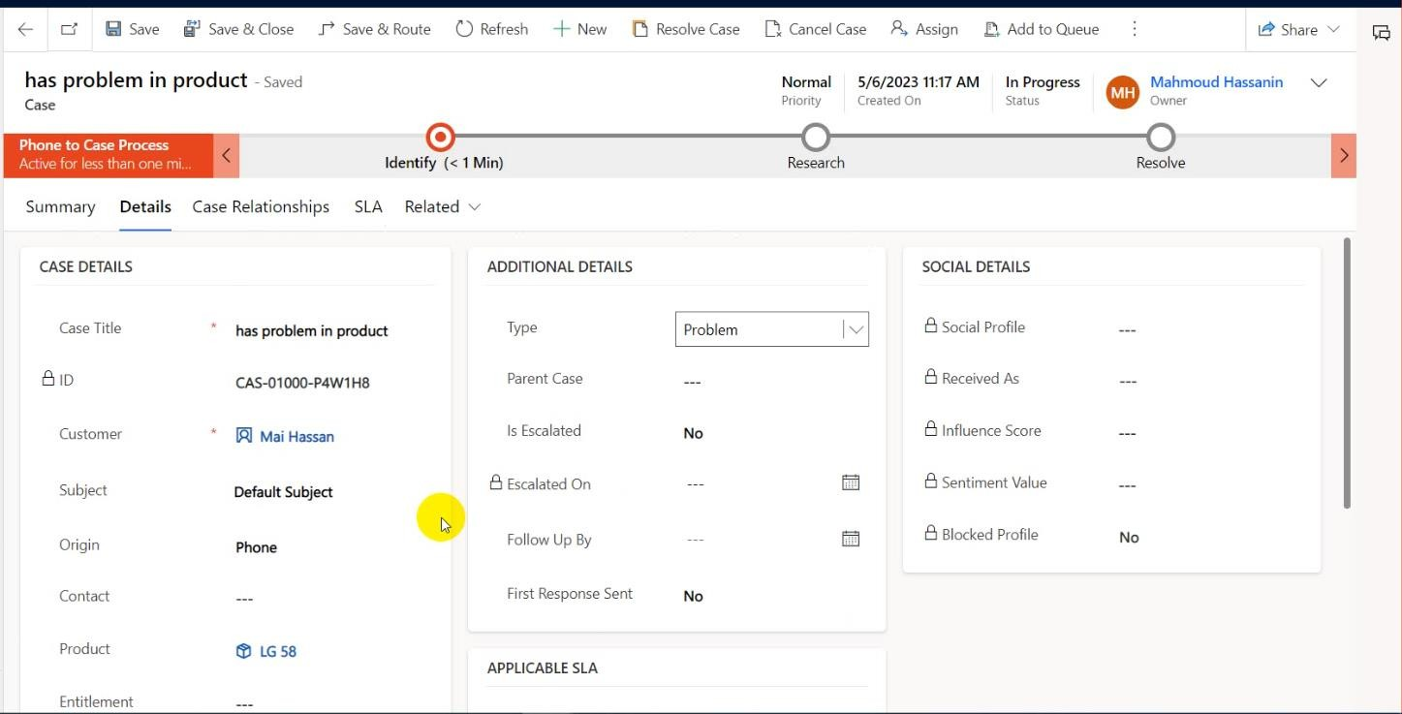

You can add parent case that must be solved before solving this case, these child cases can be added from **Case Relationships** tab also you can merge cases in this tab and knowledge base can be added too.

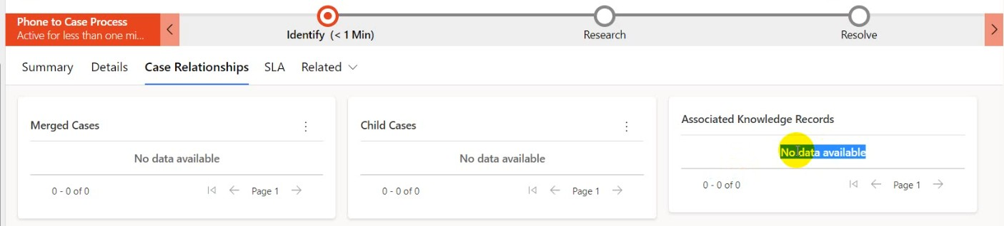

Knowledge base (like if you call technical support for an issue this customer support agent has some steps to solve this issue for example: Check speed, Restart router and reset it…).

SLA. (Service level agreement)(المفروض المشكلة تتحل في قد ايه) this refers to a contract between customer and service provider to solve this case in this period likely KPI.

You can create SLA or Entitlement from Advanced settings->

Services management-> SLA or Entitlement.

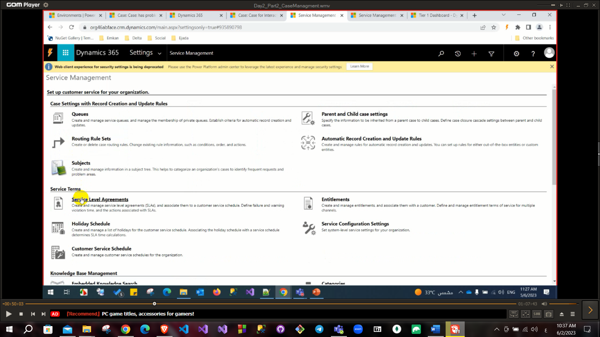

Open sla and create new

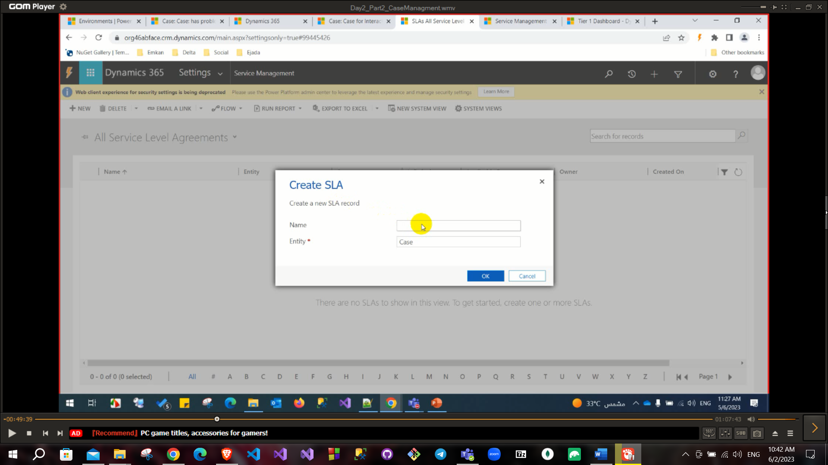

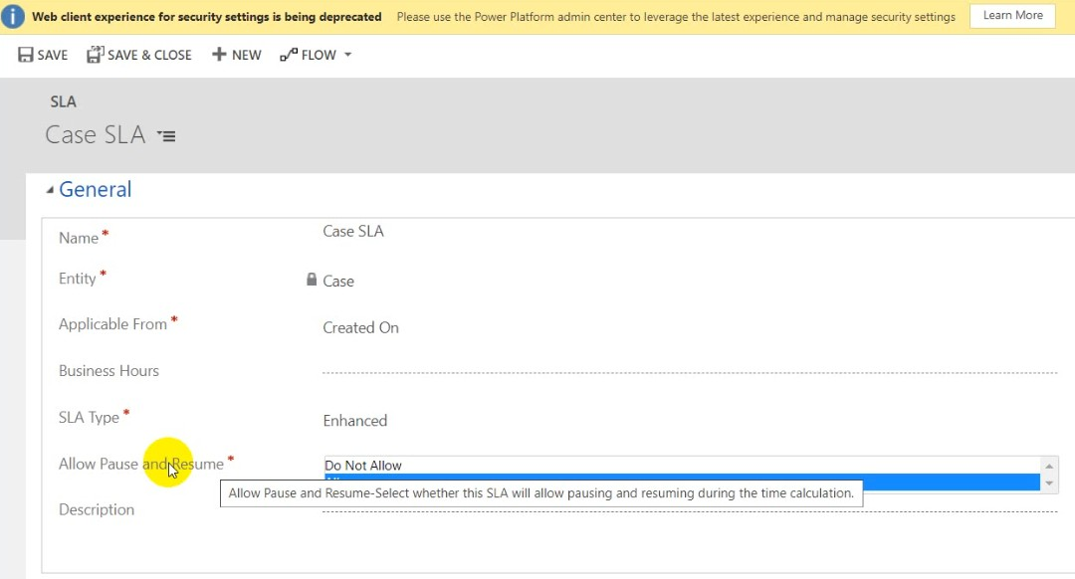

Business hours to know working hours to avoid counting time on case during vacations or off-time.

**Allow Pause and resume** also important in case you need a document from customer so, you want to pause this case till this customer send this document SLA does not work till you add new SLA item.

|  |  |
| --- | --- |
| **Standard SLA** | **Enhanced SLA** |
| Only failure time is tracked and saved in the case record. | A KPI record is created for each SLA KPI that is tracked. |
| A timer has to be manually created and added to the case form. | Timers are automatically created and added to the case form with their statuses and failure and warning times visible. |
| Timers cannot be paused, and you cannot see the time for which a case was on hold and the last time it was put on hold | Timers can be paused, and you can see the time for which a case was on hold and the last time it was put on hold. |

After creating sla we must add sla item

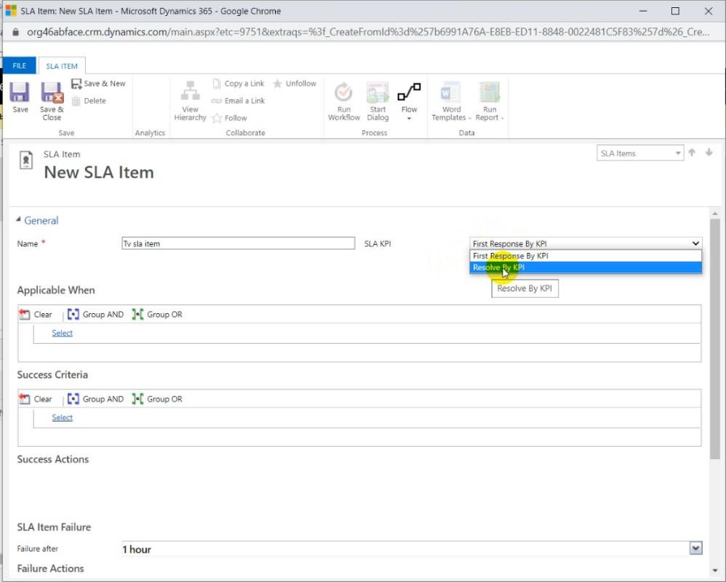

You can define it as (First response by KPI or Resolve by KPI) Also, you need to define:

Applicable when: (When this SLA will be applicable) for example to apply it on specific subject.

Success Criteria: when this SLA is marked as solved or succussed also you need to set action on success case like send email to customer.

SLA item failure: when you can say that this case is failed and need to set failure after time and set failure action (update record for example) like setting isescalated= true in the case form.

SLA item Warning: when you can say that this case is under warning situation and need to set warn after time and set a warning action.

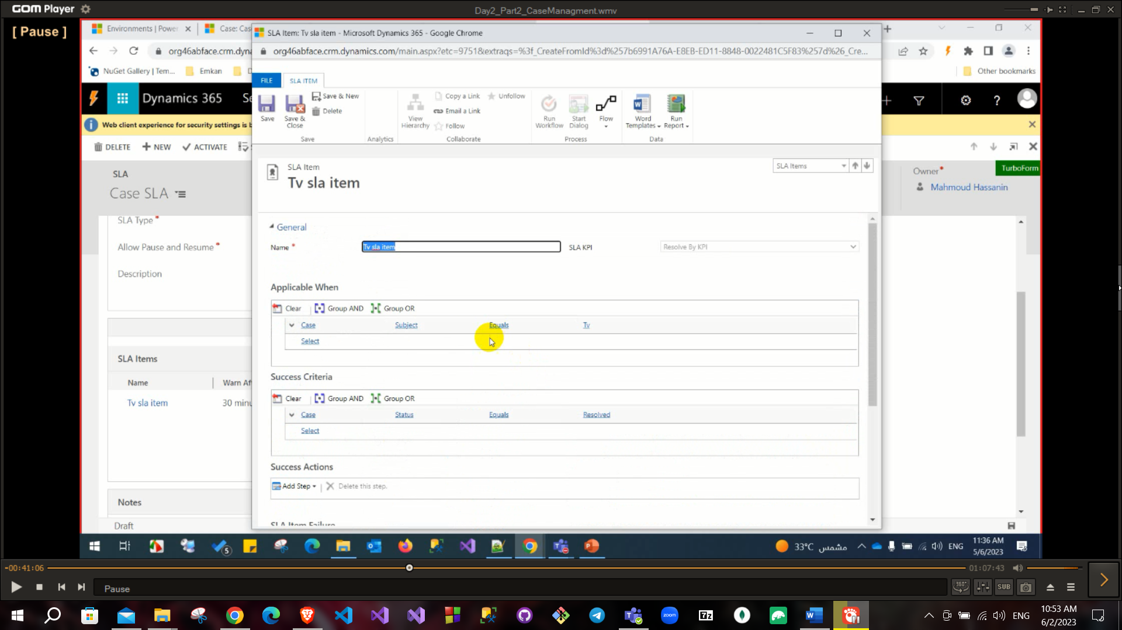

In Form assistant can bind customer email or any data you want.

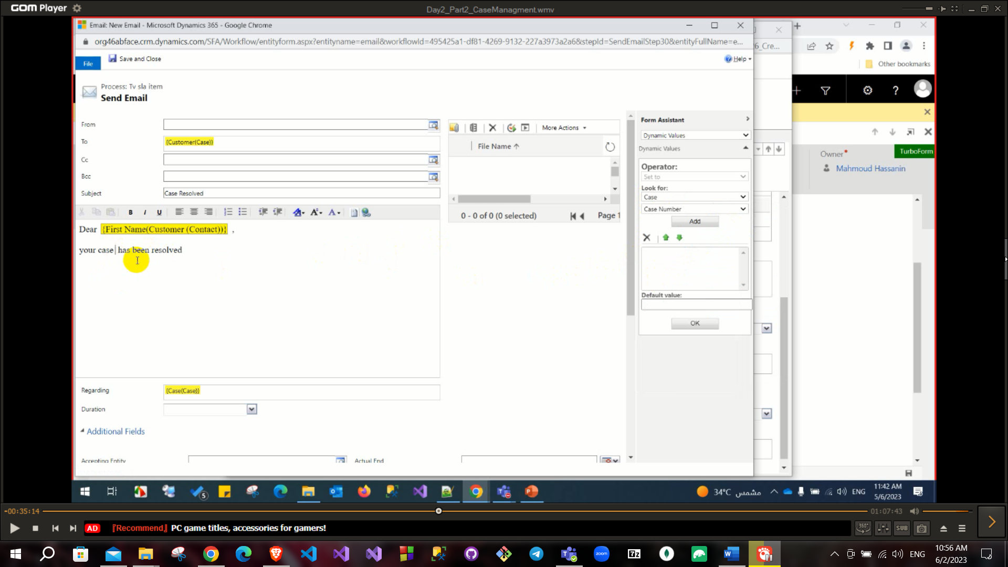SLA worked in workflow.

The sla is added to the case

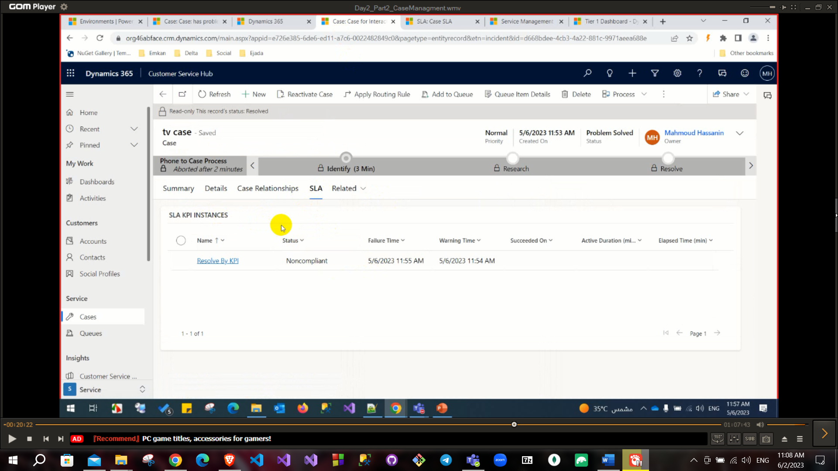

Then open the case and click resolve

Queue: to create a queue to set all case that match specific criteria to specific queue (members can pick from this queue)

From advanced settings->service management ->create queue

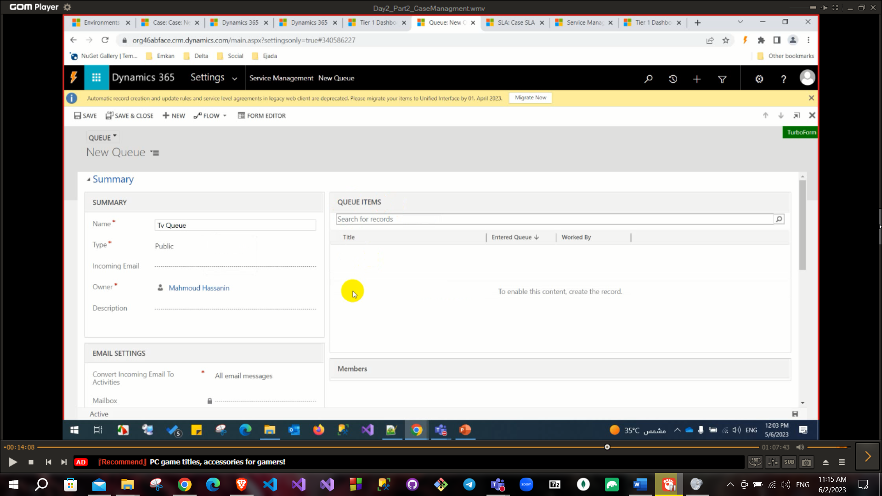

Routing rule Set: you can also find in service management used

To automate routing cases to queue or user or team.

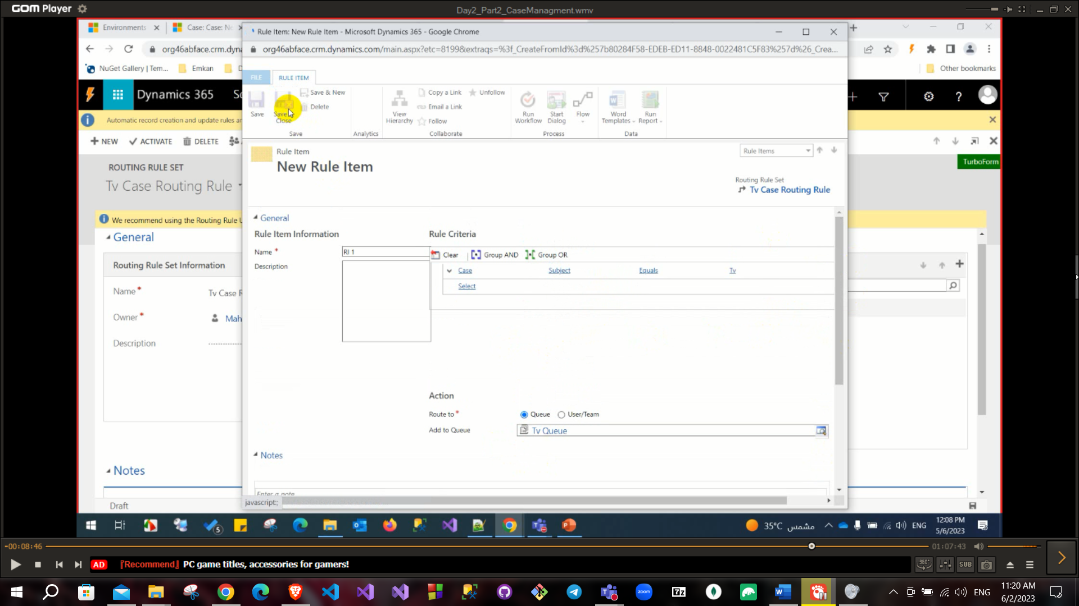

After creating case you can click on **save and route** button to assign user to solve it.

After assignment case into queue, you can click on **Pick** button to assign yourself as owner for this case and it will be removed from the queue.

SLA & Entitlement are found in Customer service admin center app: Service terms.

# Service Scheduling

## Service, Resources, Service Activities and Recurring Appointment.

Services: services that your application provide it (like shipment service)

Facilities/Equipment: Facility or Equipment that work to fulfill this service (like Car or delivery guy) you can set working hours to this resource.

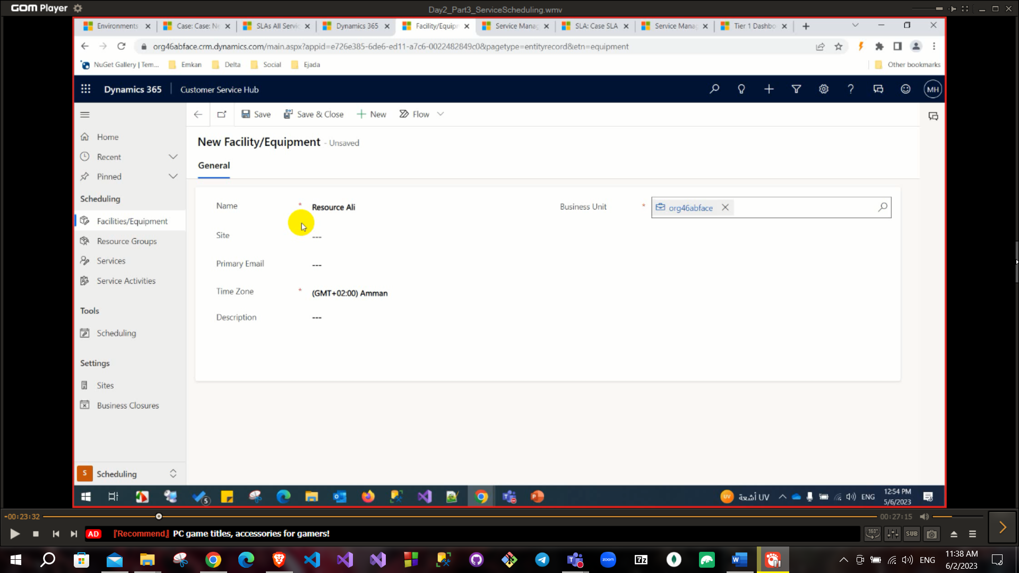

You can add a site like nasr city from the sites entity

Resource group: it is a group of facilities and equipment which are working together also you can add user or resource group or team.

Then create a service

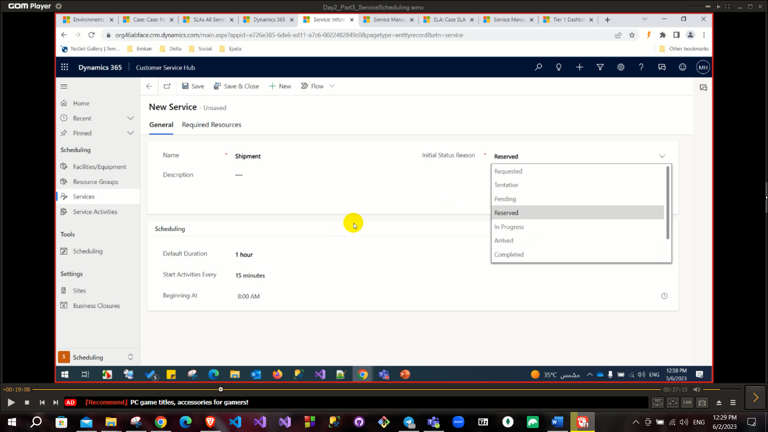

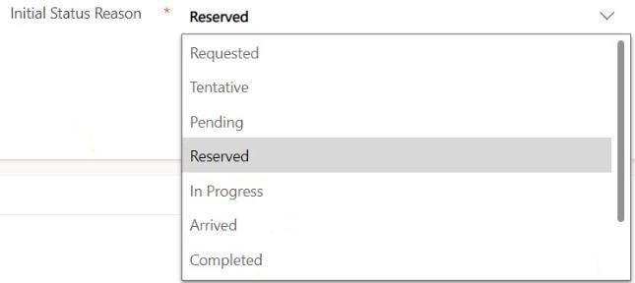

When you create a service, you can set initial status reason from this drop-down list.

## default duration:

default duration for this services.

**start activities every**: this is like a break between every activity.

Service Activities: like a case of your service (if you provide services for delivery here service activities can be order to deliver product).

Scheduling: you can see all service activities or resources to know who has assignment and who not.

Sites: Like area of your services.

You can create service activities

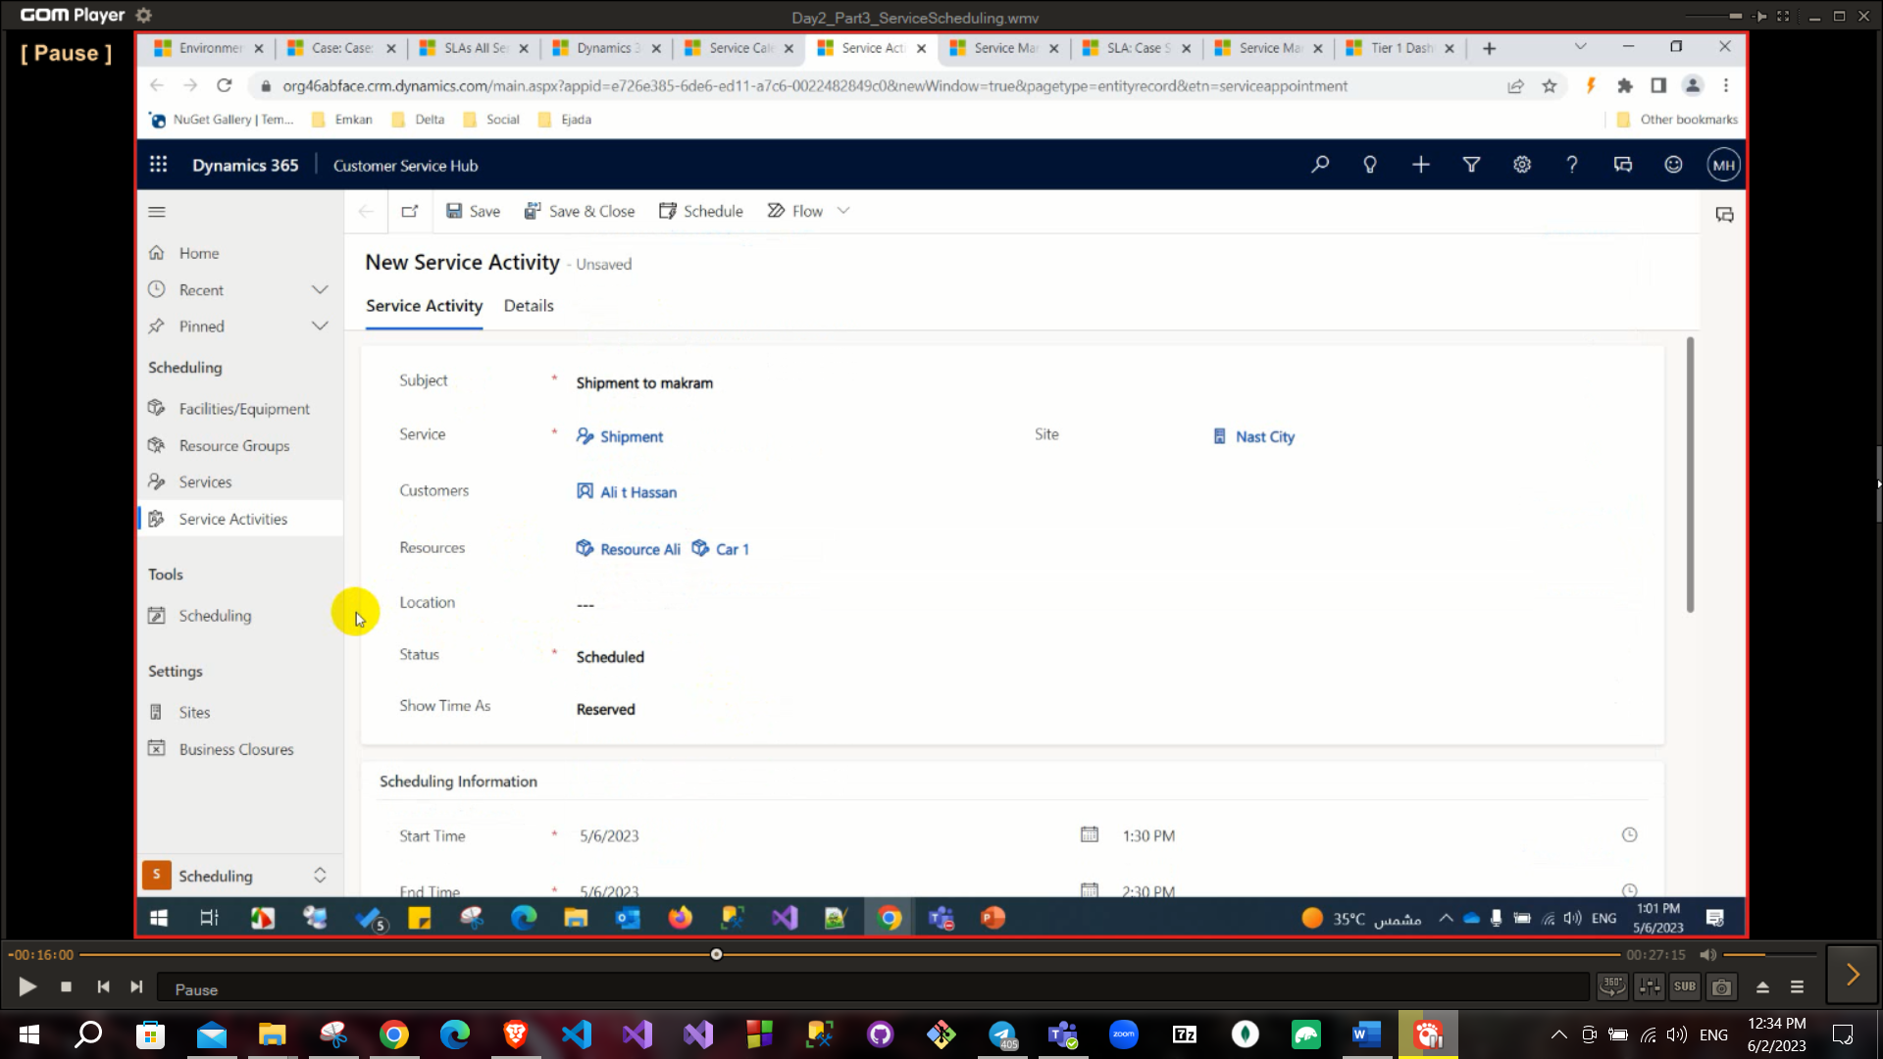

**You cannot add two service activities at the same time (cannot share the same resources).

**You can add **selection rule** to select resources to execute your services activities this is found in tab **required resources** in **Service** entity.

1. **Goal Management.**

# Goal Management

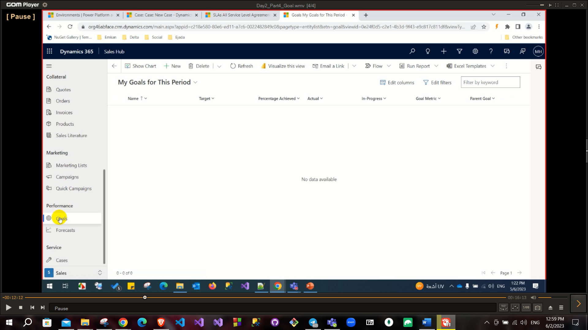

Goal: You can set a goal to track user target this will be found in Performance section.

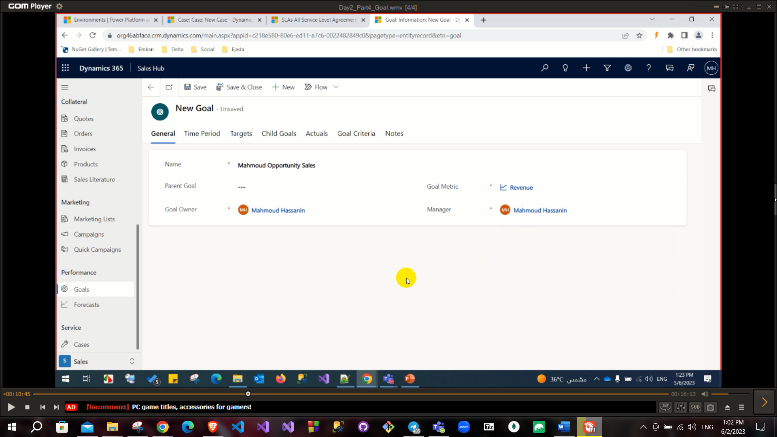

When you create a goal, you need to set a goal metric like a measurement of your goal there are three out of the box types (No. of product units, Revenue, No. of cases) also, you can create a new one to be amount(ex:goal to reach 1000dollars/day) or count(ex:to solve 4 cases every day).

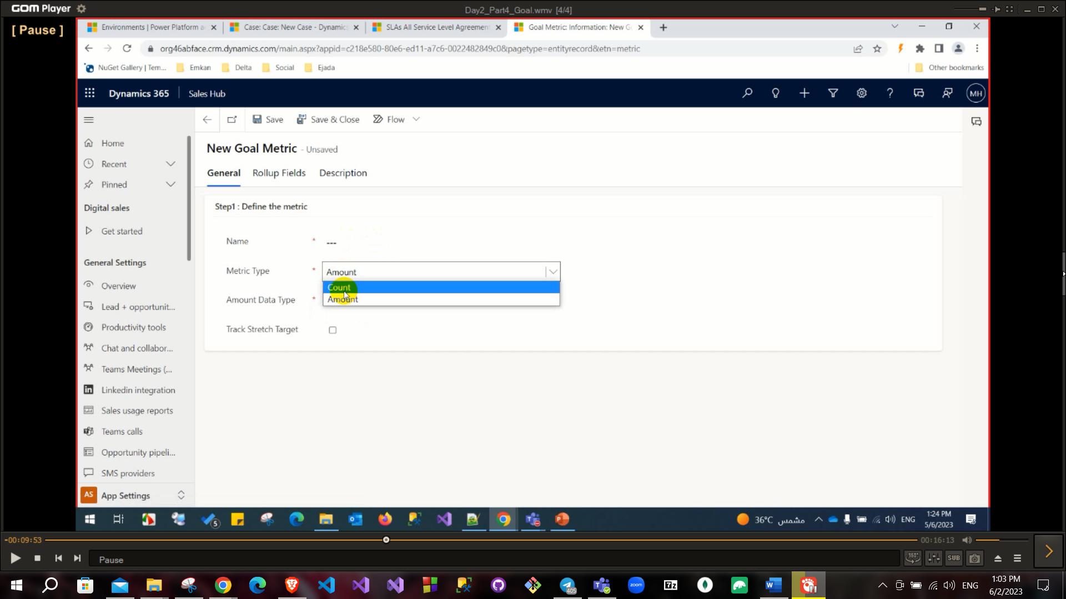

You will add the thing that your goal will apply on it in **Rollup field:** that will calculate summation of this field and check your goal and compare it with targets.

Also, there is a field called parent goal to set a parent of this goal (this parental goal will not achieve till his child goals achieved).

To track goals from charts